Text Splitters
27.06.2025

Text Splitters
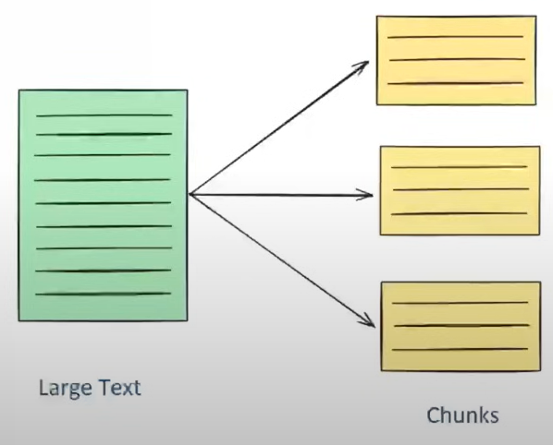
Text splitting is the process of breaking large chunks of text (like articles , PDFs , HTML pages , or books) into smaller , manageable pieces (chunks) that an LLM can handle effectively.

Benefits of using Text Splitters :
- Many embedding models and LLMs have maximum input size constraints. Splitting allows them to process documents that are now in small chunks. Easy to get their context via embeddings as one large text cannot represent correct context in just one embedding.

- Improved various LLM tasks :
- Embedding
- Semantic Search
- Summarization
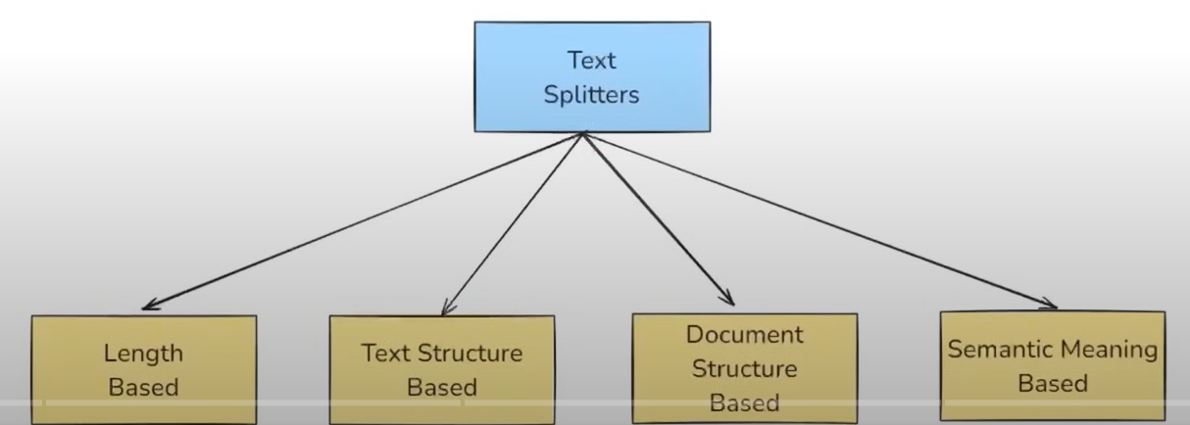

Length Based Text Splitting
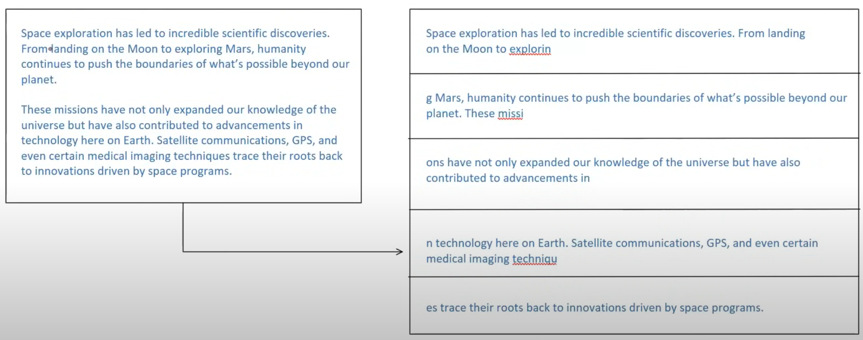
Splitting on the basis of characters. The problem is that even if words break , they have no meaning at all. We can even load a PDF and split it and each chunk created is also a document object. Splitting is done on the basis of chunk_size.

Text Structured Based Splitting
Splitting on the basis of “\n\n” (paragraph) , “\n” (new line) , “ ” (words ), “ ” (character).
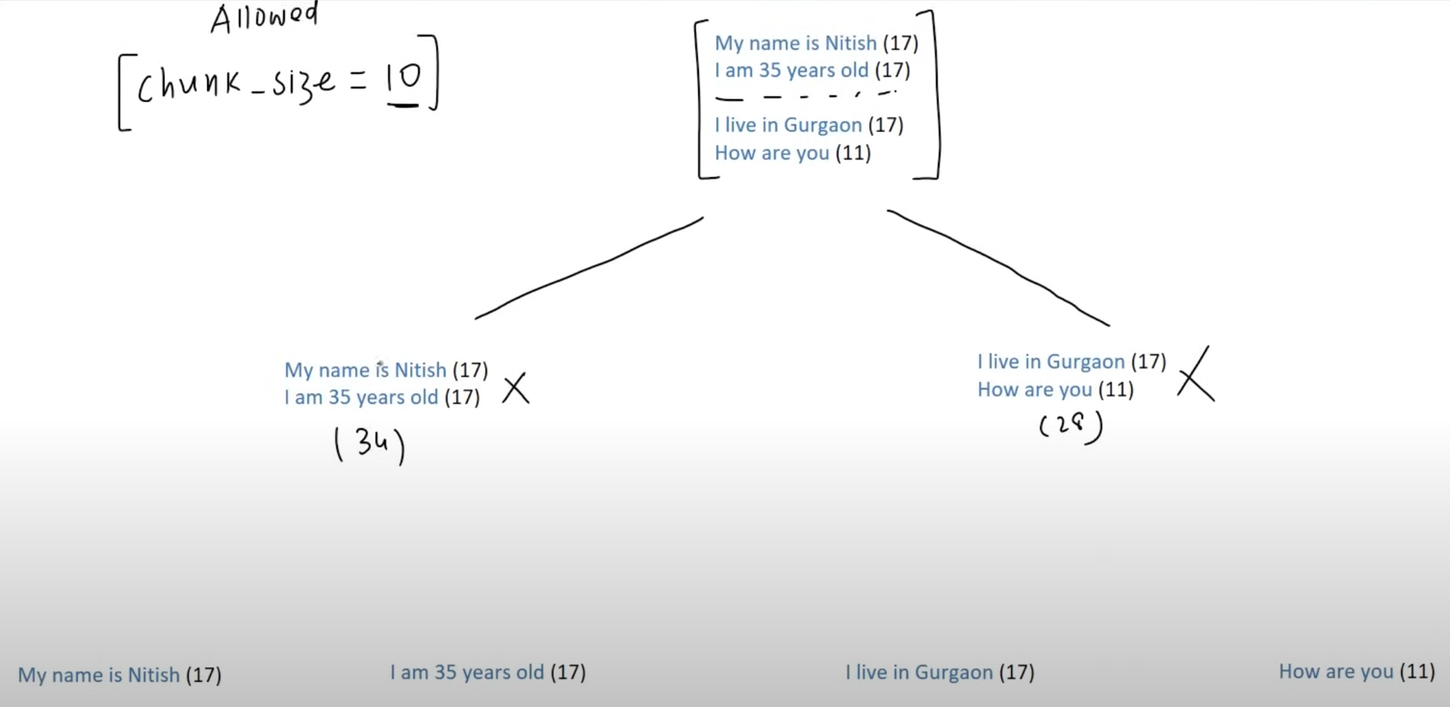
Mostly used for splitting because words do not cut here and most precise splitting.

Document-Structure Based Splitting
When we need to split documents having python code or markup documents. Here we cannot classify on the basis of para or line . There is “\nclass” , “\ndef” .
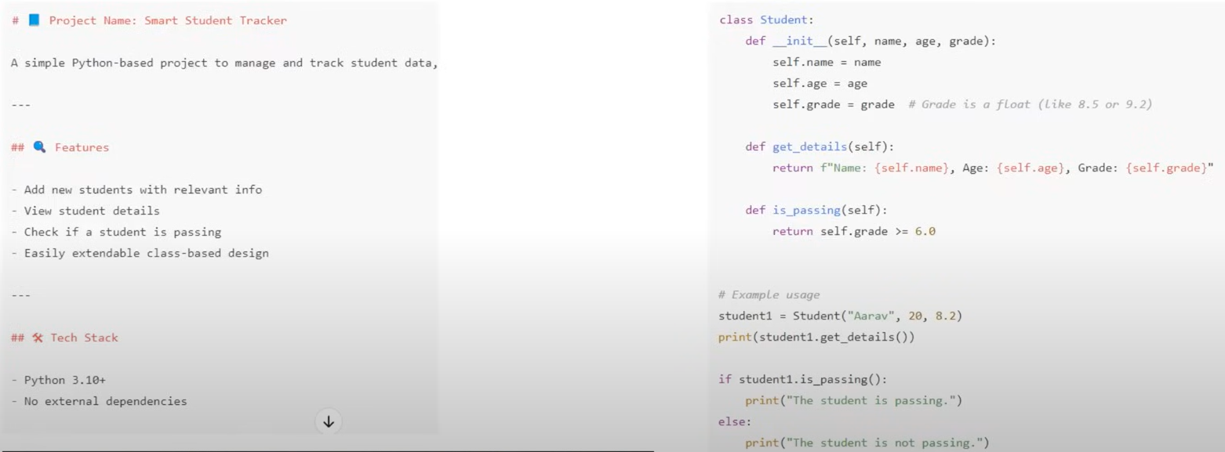

Semantic meaning based Splitting
When two paragraphs with no similarity merged with each other they cause difficulty to identify them. Semantic splitting causes each line break to calculate their respective embeddings , calculate consecutive dot products where similarity is low and found to be different context paragraphs or lines.
